Difference-in-Difference Models

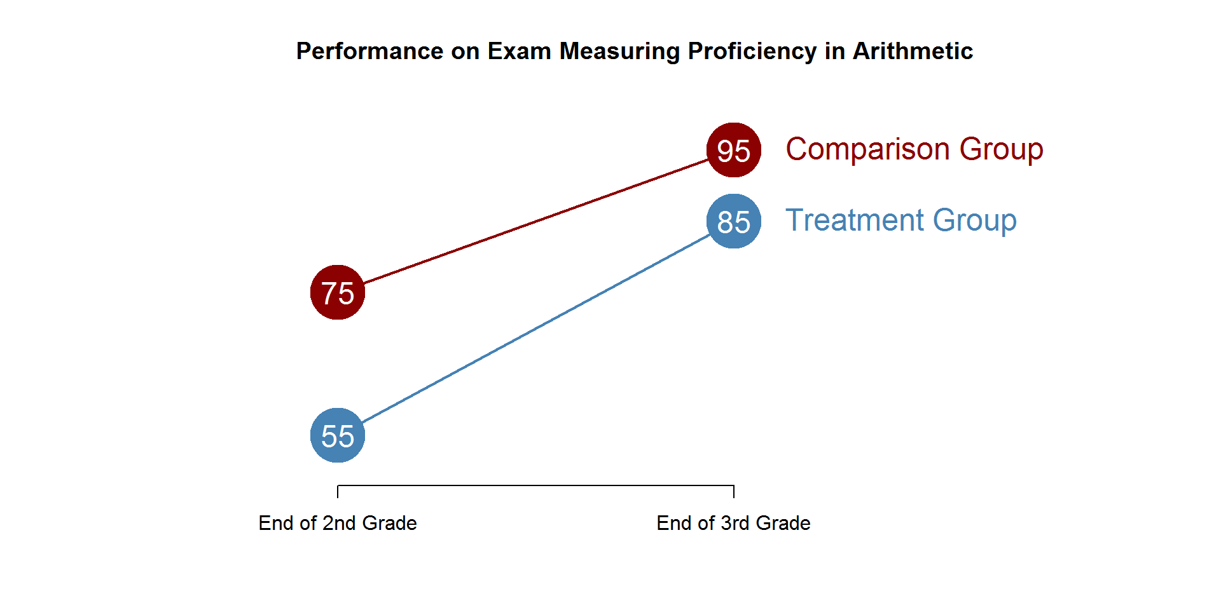

**Using the diagram above calculate the following:**

1. Trend (C2 – C1):
2. The Counterfactual: T1 + Trend
3. Total Treatment Gains (T2 – T1):

1. Program Effects: Total Gains – Trend

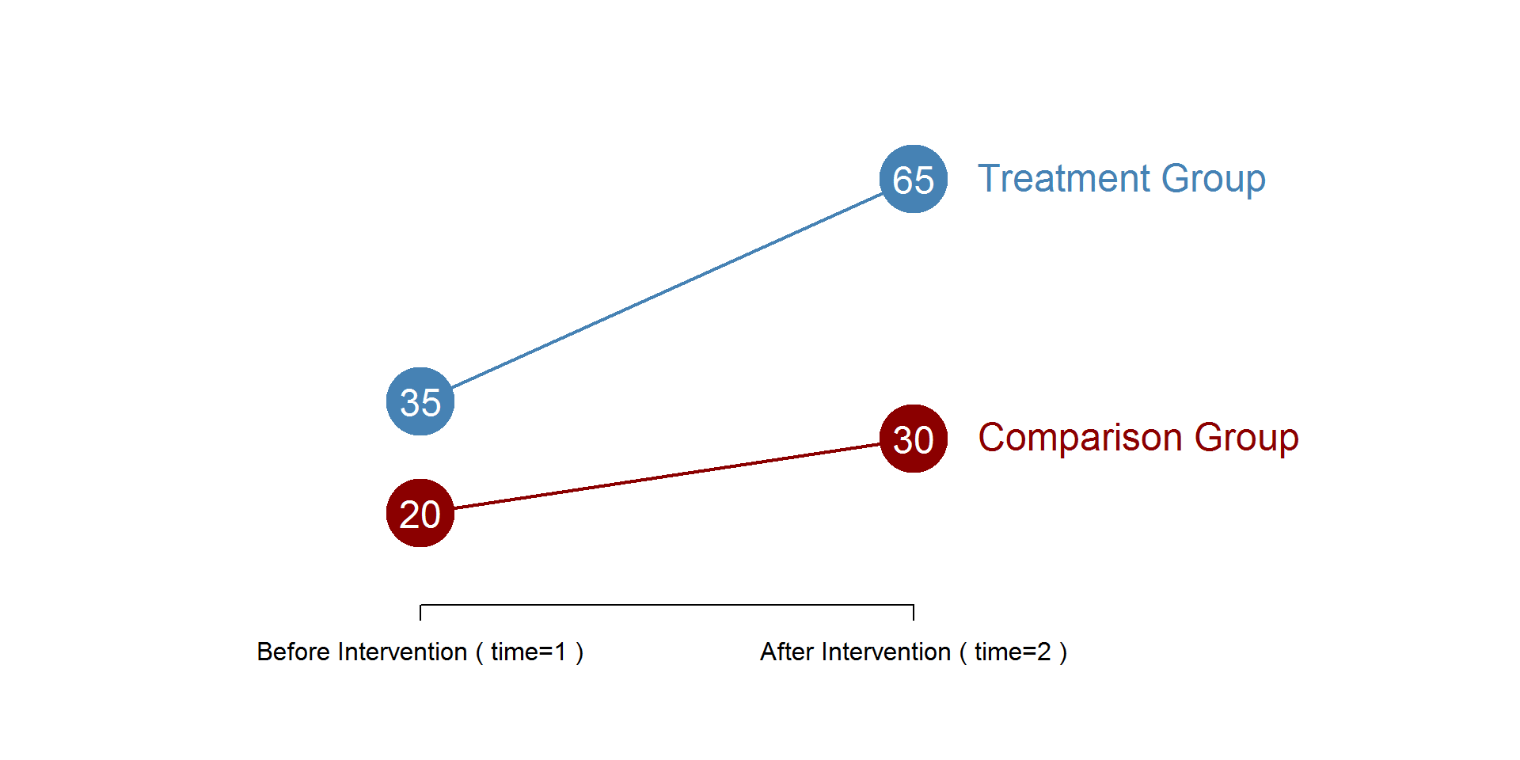



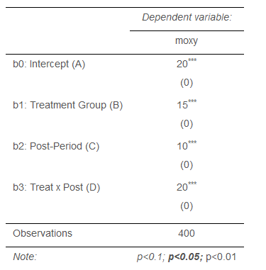 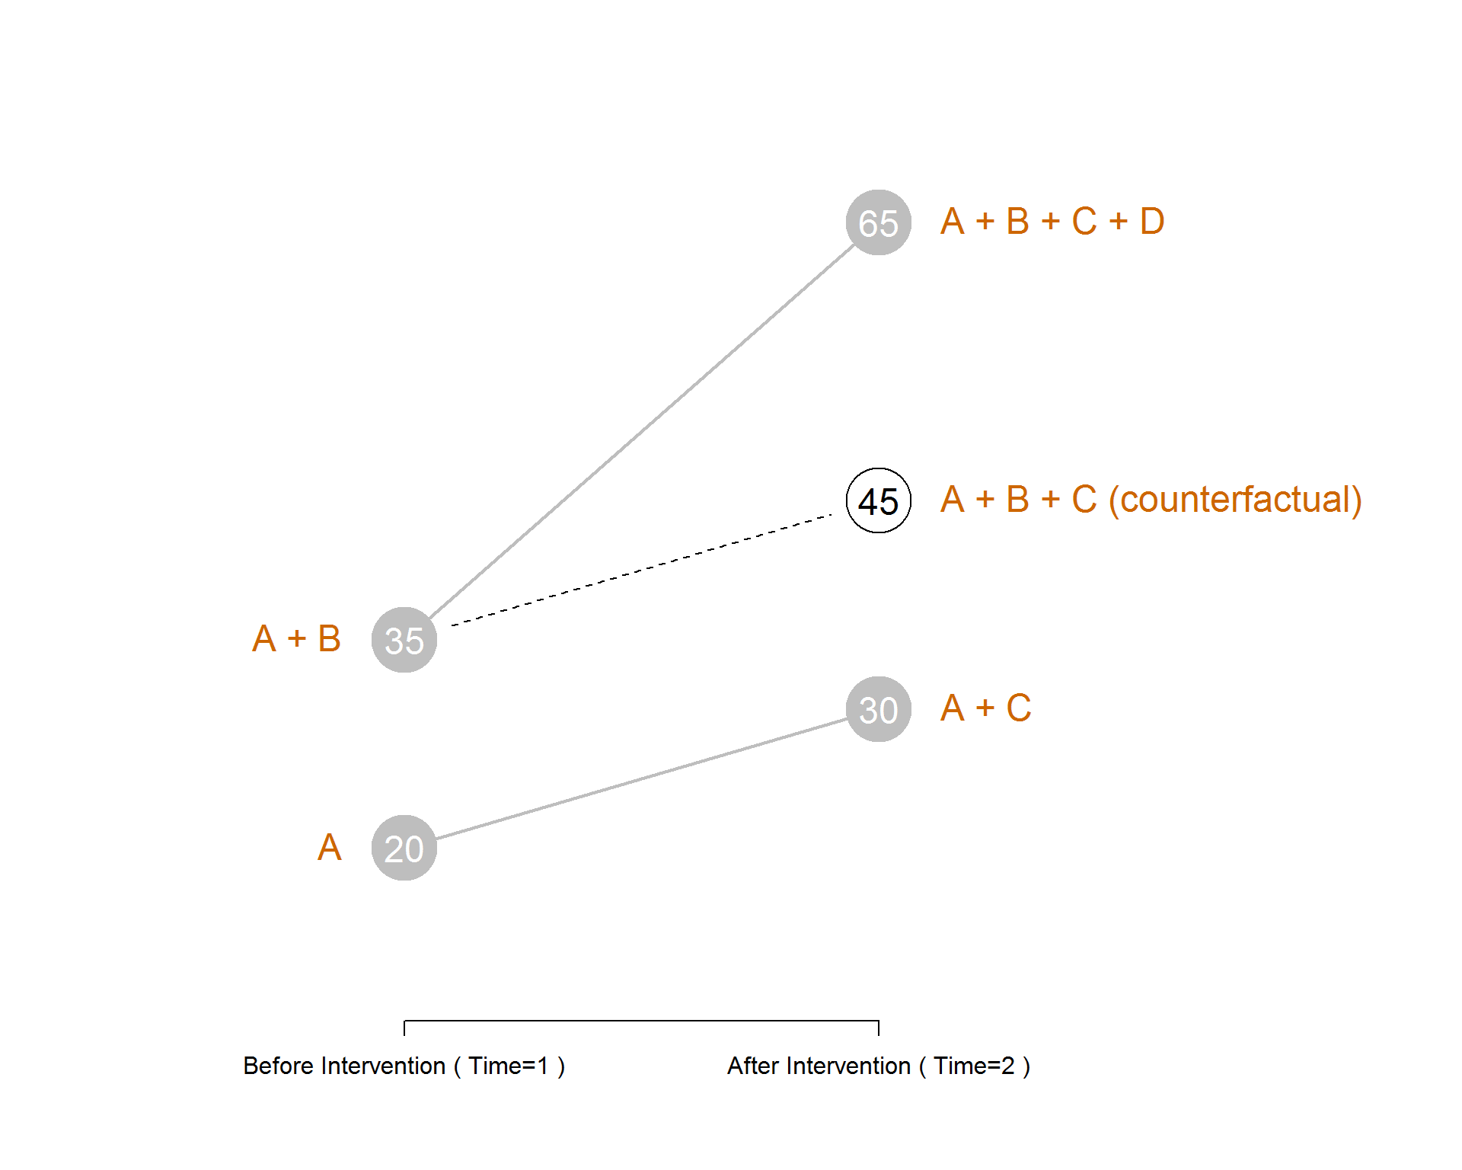

**Use the results from the difference-in-difference regression table above to answer the following:**

1. What is the group mean for C1?
2. What is the group mean for T1?
3. What is the group mean for C2?
4. What is the counterfactual?
5. Does this program have an impact, and if so how much (effect size)?

Regressions with Interaction Effects

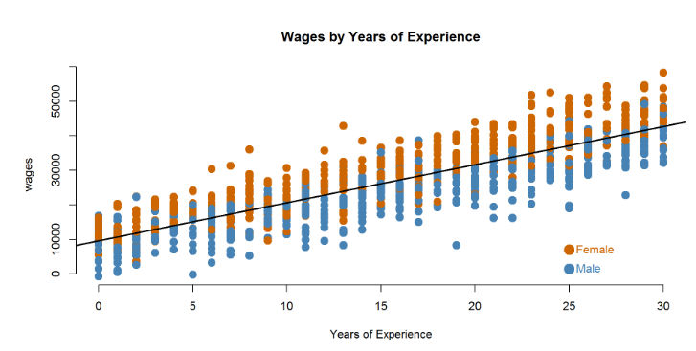

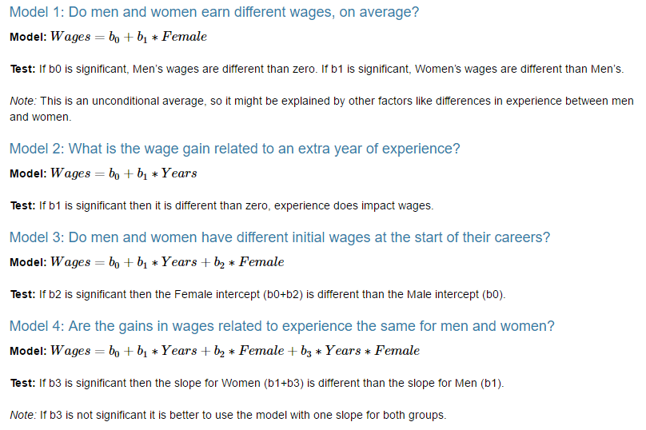

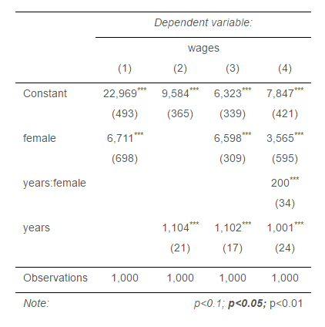

**Use Model 4 to answer the following questions:**

1. How much do men earn in their first job (zero years of experience)?
2. How much do women earn in their first job?
3. What is the average raise men receive each year?
4. Do men and women receive different raises? How do we know?
5. What is the average raise women receive each year?

Varying Effects by Groups: Corn Hybrids

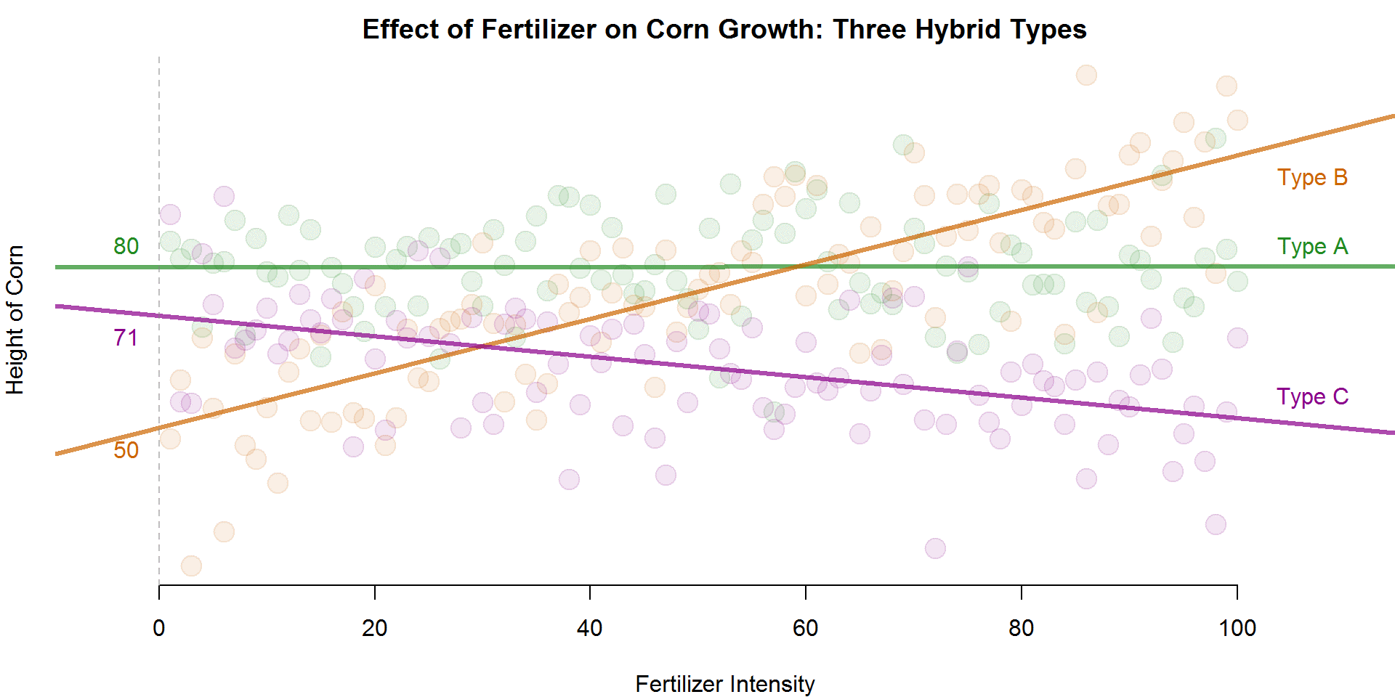

**Use the table below to answer the following questions:**

1. What is the average height of Hybrid A corn?

1. What is the average height of Hybrid A without fertilizer?

1. For each unit of fertilizer added, how much will Hybrid A grow?

1. Which hybrid grows best at low levels of fertilizer? High levels?

